**Assignment -4**

WOWKI and IBM Cloud

|  |  |
| --- | --- |
| Assignment Date | 20 October 2022 |
| Student Name | Ms. JANANAE.M |
| Student Roll Number | 710019106017 |
| Maximum Marks | 2 Marks |

**QUESTION:**

Write code and connections in Wokwi for the ultrasonic sensor. Whenever the distance is less than 100 cms send an "alert" to the IBM cloud and display in the device recent events. Upload document with Wokwi share link and images of IBM cloud.

**CODE:**

//to detect the object within 100cms

long duration;

float distance;

void setup() {

  pinMode(9, OUTPUT);

  pinMode(7, INPUT);

  pinMode(12,OUTPUT);

}

void loop() {

   duration=pulseIn(7,HIGH);

   distance=0.034*(duration/2);

   if (distance < 100)

   {

     digitalWrite(12,HIGH);

     delay(250);

   }

   else{

     digitalWrite(12,LOW);

   }

}

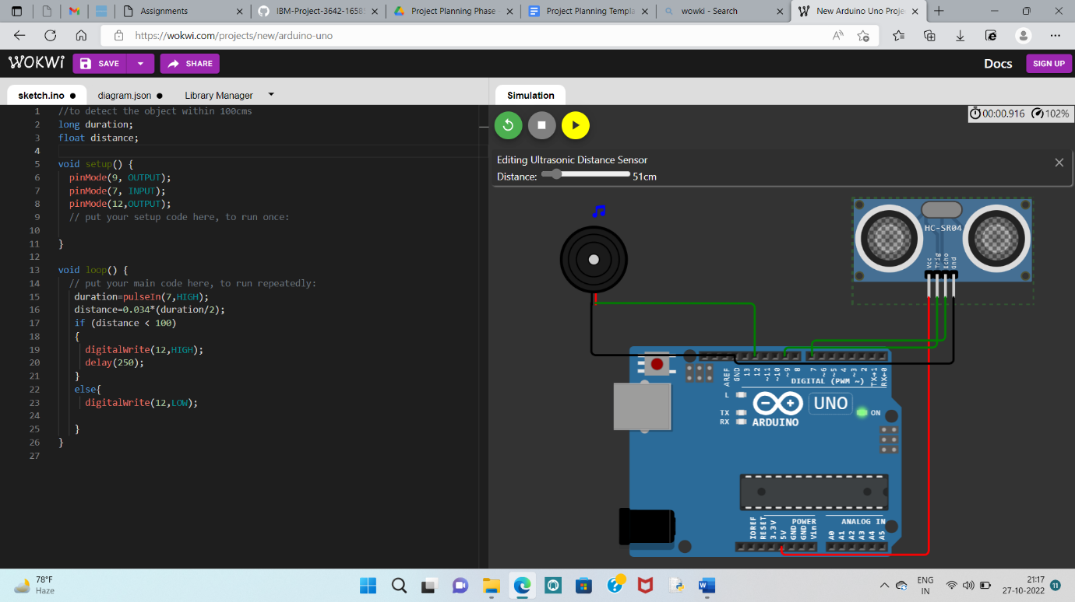**CIRCUIT:**

**WOWKI LINK:**

<https://wokwi.com/projects/346687372196315732>

**IBM CLOUD:**

